From: <https://theintercept.com/2017/04/07/the-spoils-of-war-trump-lavished-with-media-and-bipartisan-praise-for-bombing-syria/>

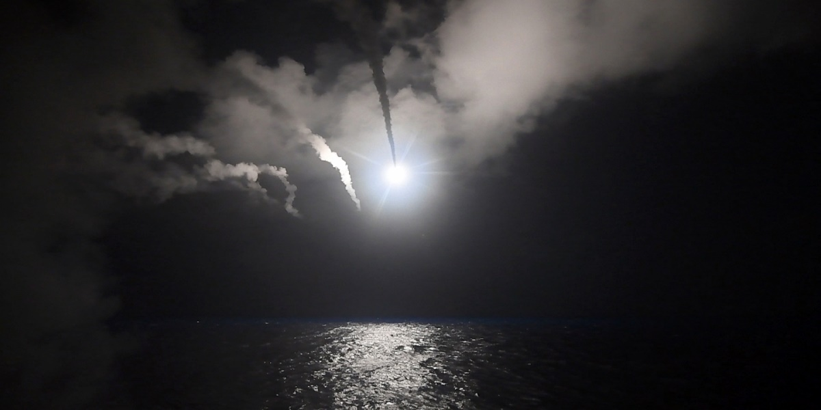

Top photo: This photo provided by the U.S. Navy, shows the guided-missile destroyer USS Porter firing a Tomahawk land attack missile on April 7, 2017 in the Mediterranean Sea at a Syrian military airfield.

Photo: Ford Williams/U.S. Navy/Getty Images

**[The Spoils of War: Trump Lavished With Media and Bipartisan Praise For Bombing Syria](https://theintercept.com/2017/04/07/the-spoils-of-war-trump-lavished-with-media-and-bipartisan-praise-for-bombing-syria/)**

[[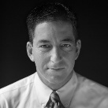](https://theintercept.com/staff/glenn-greenwald/)Glenn Greenwald](https://theintercept.com/staff/glenn-greenwald/)

April 7 2017, 10:43 a.m.

**IN EVERY TYPE** of government, nothing unites people behind the leader more quickly, reflexively or reliably than war. Donald Trump now sees how true that is, as the same establishment leaders in U.S. politics and media who have spent months denouncing him as a mentally unstable and inept authoritarian and unprecedented threat to democracy are standing and applauding him as he launches bombs at Syrian government targets.

Trump, on Thursday night, ordered an attack that [the Pentagon said](https://www.defense.gov/News/Article/Article/1144601/trump-orders-missile-attack-in-retaliation-for-syrian-chemical-strikes) included the launching of 59 Tomahawk missiles which “targeted aircraft, hardened aircraft shelters, petroleum and logistical storage, ammunition supply bunkers, air defense systems, and radars.” The governor of Homs, the Syrian province where the attack occurred, [said early this morning](https://apnews.com/3ff72134947d46288c8e210f07dce32a?utm_campaign=SocialFlow&utm_source=Twitter&utm_medium=AP) that the bombs killed seven civilians and wounded nine.

The Pentagon’s statement said the attack was “in retaliation for the regime of Bashar Assad using nerve agents to attack his own people.” Both Syria and Russia vehemently deny that the Syrian military used chemical weapons.

When asked about this yesterday by the Globe and Mail’s Joanna Slater, Canadian Prime Minister Justin Trudeau [urged an investigation](https://twitter.com/jslaternyc/status/850164875368296450) to determine what actually happened before any action was contemplated, citing what he called “continuing questions about who is responsible”:

[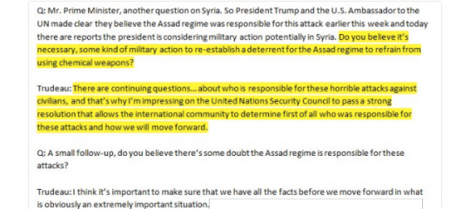](https://prod01-cdn07.cdn.firstlook.org/wp-uploads/sites/1/2017/04/trudeau1-1491565233.png)

But U.S. war fever waits for nothing. Once the tidal wave of American war frenzy is unleashed, questioning the *casus belli* is impermissible. Wanting conclusive evidence before bombing commences is vilified as sympathy with and support for the foreign villain (the same way that asking for evidence of claims against Russia instantly converts one into a “Kremlin agent” or “stooge”).

That the Syrian government deliberately used chemical weapons to bomb civilians became absolute truth in U.S. discourse within less than 24 hours – even though Trudeau urged an investigation, even though it was denied in multiple capitals around the world, and even though Susan Rice just two months ago [boasted to NPR](http://www.npr.org/sections/parallels/2017/01/16/510047606/obama-adviser-susan-rice-cites-syrian-war-as-biggest-disappointment?platform=hootsuite): “We were able to get the Syrian government to voluntarily and verifiably give up its chemical weapons stockpile.”

Whatever happened with this event, the Syrian government has killed hundreds of thousands of people over the past five years in what began as a citizen uprising in the spirit of the Arab Spring, and then morphed into a complex proxy war involving foreign fighters, multiple regional powers, ISIS, Al Qaeda, and Russia.

The CIA has spent more than a billion dollars a year to [arm anti-Assad rebels for years](https://www.washingtonpost.com/world/national-security/lawmakers-move-to-curb-1-billion-cia-program-to-train-syrian-rebels/2015/06/12/b0f45a9e-1114-11e5-adec-e82f8395c032_story.html), and the U.S. began bombing Syria in 2014 – the 7th predominantly Muslim country [bombed by Obama](https://theintercept.com/2014/09/23/nobel-peace-prize-fact-day-syria-7th-country-bombed-obama/) – and never stopped. Trump had already escalated that bombing campaign, culminating in a strike last month that Syrians say [destroyed a mosque and killed dozens](https://theintercept.com/2017/03/17/pentagon-denies-bombing-syrian-mosque-but-its-own-photo-may-prove-that-it-did/). What makes this latest attack new is that rather than allegedly targeting terrorist sites of ISIS and Al Qaeda, it targets the Syrian government – something Obama [threatened to do in 2013](https://www.theguardian.com/world/2013/sep/03/obama-strategy-assad-republicans-syria) but never did.

Leading Congressional Democrats – including Senate Minority Leader Chuck Schumer and House Minority Leader Nancy Pelosi – [quickly praised Trump’s bombing](https://twitter.com/BresPolitico/status/850185703367602176) while raising concerns about process. Hours before the bombing commenced, as it was known Trump was planning it, Hillary Clinton – who has been critical of Obama for years for not attacking Assad – appeared at an event and offered her categorical support for what Trump was planning:

[[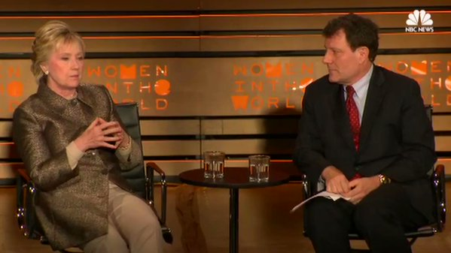](https://twitter.com/NBCNews/status/850162697354326016)](https://twitter.com/NBCNews/status/850162697354326016)

**[Follow](https://twitter.com/NBCNews" \o "Follow NBC News on Twitter)**

[https://pbs.twimg.com/profile_images/721554521957138436/tTocueCd_normal.jpg](https://twitter.com/NBCNews)**[NBC News](https://twitter.com/NBCNews)**

[✔@NBCNews](https://twitter.com/NBCNews)

WATCH: Hillary Clinton said U.S. should attack Assad's airfields hours before missile strike. More: [http://nbcnews.to/2o34p6W](https://t.co/BQ6AEMNpZh)

[9:45 PM - 6 Apr 2017](https://twitter.com/NBCNews/status/850162697354326016)

[4,9414,941 Retweets](https://twitter.com/intent/retweet?tweet_id=850162697354326016)

[5,7695,769 likes](https://twitter.com/intent/like?tweet_id=850162697354326016)

The Trump White House is preliminarily indicating that this was a limited strike, designed to punish Assad for his use of chemical weapons, rather than a new war to remove him. But such aggression, once unleashed, is often difficult to contain. The Russian and Iranian governments, both supportive of Assad, have [bitterly denounced Trump for the attack](https://www.nytimes.com/2017/04/07/world/middleeast/russia-iran-us-strikes-syria.html?_r=0), with a Putin spokesman calling it a “significant blow” for U.S.-Russian relations. Russia already [announced retaliation](http://www.politico.com/story/2017/04/russia-responds-us-syria-air-strikes-236989) in the form of suspending cooperation agreements.

Even if it is contained, there are endless implications from Trump’s initiation of military force against the Syrian Government. For now, here are ten critical points highlighted by all of this:

**1. New wars will always strengthen Trump: as they do for every leader.**

The instant elevation of Trump into a serious and respected war leader was palpable. Already, the New York Times [is gushing](https://www.nytimes.com/2017/04/07/world/middleeast/airstikes-syria-trump-russia.html?smid=tw-share)that “in launching a military strike just 77 days into his administration, President Trump has the opportunity, but hardly a guarantee, to change the perception of disarray in his administration.”

Political leaders across the spectrum rushed to praise Trump and support his bombing campaign. Media coverage was overwhelmingly positive. One consummate establishment spokesman [accurately observed](https://twitter.com/ianbremmer/status/850176828971114496):

**[Follow](https://twitter.com/ianbremmer" \o "Follow ian bremmer on Twitter)**

[https://pbs.twimg.com/profile_images/800980647380742144/F9d8jxj0_normal.jpg](https://twitter.com/ianbremmer)**[ian bremmer](https://twitter.com/ianbremmer)**

[✔@ianbremmer](https://twitter.com/ianbremmer)

Among US political establishment, attacks on Assad the most popular action Trump has taken to date as President.

[10:42 PM - 6 Apr 2017](https://twitter.com/ianbremmer/status/850176828971114496)

[463463 Retweets](https://twitter.com/intent/retweet?tweet_id=850176828971114496)

[761761 likes](https://twitter.com/intent/like?tweet_id=850176828971114496)

New wars trigger the worst in people: their jingoism, their tribal loyalties, their instinct to submit to authority and leaders. The incentive scheme here is as obvious as it is frightening: great rewards await political leaders who start new wars. In [Federalist 4](http://www.constitution.org/fed/federa04.htm), John Jay warned of all the personal benefits a leader obtains from starting a new war – which is the reason it was supposed to be difficult for U.S. Presidents to do it:

It is too true, however disgraceful it may be to human nature, that nations in general will make war whenever they have a prospect of getting anything by it; nay, absolute monarchs will often make war when their nations are to get nothing by it, *but for the purposes and objects merely personal*, such as thirst for military glory, revenge for personal affronts, ambition, or private compacts to aggrandize or support their particular families or partisans. These and a variety of other motives, which affect only the mind of the sovereign, often lead him to engage in wars not sanctified by justice or the voice and interests of his people.

Trump is going to see – and feel – the establishment and media respect he craves, the sensations of strength he most lacks, by dropping bombs. Every person, let alone Trump, would be tempted to keep pursuing war as a result of this warped incentive framework. Indeed, Trump himself has long been aware of this motivation as he accused Obama in 2012 of preparing to start a new war in response to falling poll numbers:

**[Follow](https://twitter.com/realDonaldTrump" \o "Follow Donald J. Trump on Twitter)**

[https://pbs.twimg.com/profile_images/1980294624/DJT_Headshot_V2_normal.jpg](https://twitter.com/realDonaldTrump)**[Donald J. Trump](https://twitter.com/realDonaldTrump)**

[✔@realDonaldTrump](https://twitter.com/realDonaldTrump)

Now that Obama’s poll numbers are in tailspin – watch for him to launch a strike in Libya or Iran. He is desperate.

[5:39 PM - 9 Oct 2012](https://twitter.com/realDonaldTrump/status/255784560904773633)

[24,62724,627 Retweets](https://twitter.com/intent/retweet?tweet_id=255784560904773633)

[14,67614,676 likes](https://twitter.com/intent/like?tweet_id=255784560904773633)

Those who instantly fall in line behind Trump as he bombs people are ensuring that he will keep doing it. As the instantly popular post-9/11 George W. Bush showed, those praising Trump for bombing Syria are also building him up in general so that he becomes stronger with everything else he wants to do.

**2. Democrats’ jingoistic rhetoric has left them no ability – or desire – to oppose Trump’s wars.**

Democrats have spent months wrapping themselves in extremely nationalistic and militaristic rhetoric. They have constantly accused Trump of being a traitor to the U.S., a puppet of Putin, and unwilling to defend U.S. interests. They have specifically tried to exploit Assad’s crimes by tying the Syrian leader to Trump, insisting that Trump would never confront Assad because doing so would anger his Kremlin masters. They have embraced a framework whereby anyone who refuses to confront Putin or Assad is deemed a sympathizer of, or a servant to, foreign enemies.

Having pushed those tactics and themes, Democrats have painted themselves into a corner. How could they possibly do anything but cheer as Trump bombs Syria? They can’t. And cheering is thus exactly what they’re doing.

For months, those of us who have urged skepticism and restraint on the Russia rhetoric have highlighted the risk that this fixation on depicting him as a tool of the Kremlin could goad Trump – dare him or even force him – to seek confrontation with Moscow. Some Democrats reacted with rage yesterday at the suggestion that their political tactics were now bearing this fruit, but that’s how politics works.

Much as George H.W. Bush was motivated to shed his “wimp” image by invading Panama, *of course*Trump will be motivated to prove he’s not controlled by Putin via blackmail by seeking confrontation with the Russian leader. And that’s exactly what he just did. War is the classic weapon U.S. Presidents use to show they are strong, patriotic and deserving of respect; the more those attributes are called in question, the greater that compulsion becomes:

[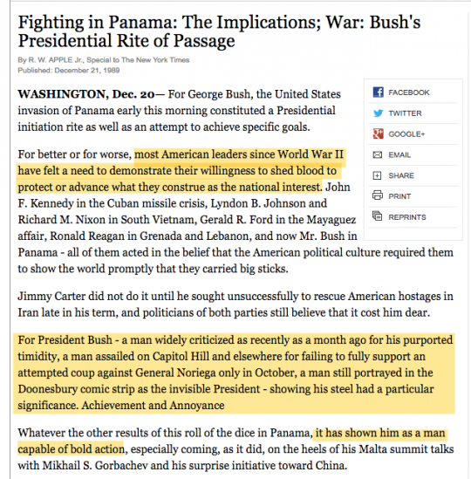](https://prod01-cdn07.cdn.firstlook.org/wp-uploads/sites/1/2017/04/nytbush-1491568970.png)

Trump is the prime author of his wars, and of this bombing in Syria. He, and he alone, bears primary responsibility for it. But Trump is not an island of agency; he operates in the climate of Washington. A major reason why it’s so dangerous to ratchet up rhetorical tension between two major nuclear-armed powers is because of the ease with which those tensions can translate into actual conflict, and the motivation it can create for Trump to use war to prove he’s a patriot after all.

Whatever else is true, Democrats – with very few exceptions such as [Rep. Ted Lieu](https://twitter.com/tedlieu/status/850139214775713793) and [Rep. Tulsi Gabbard](https://twitter.com/TulsiPress/status/850198159372427266) – have refrained from criticizing Trump’s bombing campaign on the merits (as opposed to process issues). Indeed, Democratic Party leaders have explicitly praised Trump’s bombing. They will have to continue to do so even if Trump expands this war. That’s what the Democratic Party has turned itself into to; indeed, it’s what it has been for a long time.

**3. In wartime, US television instantly converts into state media.**

As it always does, the U.S. media last night was an almost equal mix of excitement and reverence as the bombs fell. People who dissent from this bombing campaign – who opposed it on the merits – were almost entirely disappeared, as they always are in such moments of high patriotism (MSNBC’s Chris Hayes had two guests on after midnight who opposed it, but they were rare). Claims from the U.S. government and military are immediately vested with unquestioned truth and accuracy, while claims from foreign adversaries such as Russia and Syria are reflexively scorned as lies and propaganda.

For all the recent hysteria over RT being a propaganda outlet for the state, U.S. media coverage is barely distinguishable in times of war (which is, for the U.S., the permanent state of affairs). More systematic analysis will surely be forthcoming of last night’s coverage, but for now, here is Brian Williams – in all of his military-revering majesty – showing how state TV functions in the United States:

[[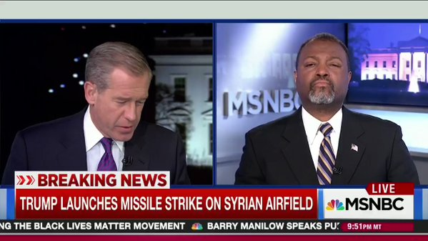](https://twitter.com/adamjohnsonNYC/status/850206506205102080)](https://twitter.com/adamjohnsonNYC/status/850206506205102080)

**[Follow](https://twitter.com/adamjohnsonNYC" \o "Follow Adam H. Johnson on Twitter)**

[https://pbs.twimg.com/profile_images/643965876090327040/MhtfHO9A_normal.jpg](https://twitter.com/adamjohnsonNYC)**[Adam H. Johnson](https://twitter.com/adamjohnsonNYC)**

[✔@adamjohnsonNYC](https://twitter.com/adamjohnsonNYC)

good thing we don't have govt-controlled media in this country

[12:40 AM - 7 Apr 2017](https://twitter.com/adamjohnsonNYC/status/850206506205102080)

[2,5812,581 Retweets](https://twitter.com/intent/retweet?tweet_id=850206506205102080)

[3,5623,562 likes](https://twitter.com/intent/like?tweet_id=850206506205102080)

And here’s Fareed Zakaria declaring on CNN that Donald Trump has now been instantly transformed into the President of the United States in all of the loftiest and most regal senses of the term:

[[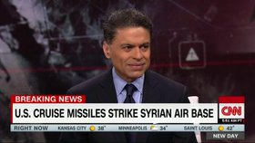](https://twitter.com/NewDay/status/850332240190083072)](https://twitter.com/NewDay/status/850332240190083072)

**[Follow](https://twitter.com/NewDay" \o "Follow New Day on Twitter)**

[https://pbs.twimg.com/profile_images/514729467890003969/KAf_Wq6L_normal.jpeg](https://twitter.com/NewDay)**[New Day](https://twitter.com/NewDay)**

[✔@NewDay](https://twitter.com/NewDay)

.[@FareedZakaria](https://twitter.com/FareedZakaria) on Syria strikes: "I think Donald Trump became President of the United States" last night

[8:59 AM - 7 Apr 2017](https://twitter.com/NewDay/status/850332240190083072)

[368368 Retweets](https://twitter.com/intent/retweet?tweet_id=850332240190083072)

[580580 likes](https://twitter.com/intent/like?tweet_id=850332240190083072)

**4. Trump’s bombing is illegal, but presidents are now omnipotent.**

It should be startling and infuriating that Trump is able to order a new attack on the Syrian Government without any democratic debate, let alone Congressional approval. At least when Obama started bombing Syria without Congress, he had the excuse that it was authorized by the 2001 Authorization to Use Military Force, since his ostensible targets were terrorist groups (even though ISIS did not exist until years after that was enacted and is hardly “affiliated” with Al Qaeda). But since there’s no self-defense pretext to what Trump just did, what possible legal rationale exists for this? [None](http://www.nytimes.com/2013/08/31/opinion/what-happened-to-the-rule-of-law.html?smid=tw-share).

But nobody in Washington really cares about such legalities. Indeed, we have purposely created an omnipotent presidency. Recall that in 2011, Obama went to war in Libya not just without Congressional approval, but even after [Congress *rejected* such authorization](http://thehill.com/blogs/floor-action/house/168347-house-rejects-libya-authorization-resolution).

[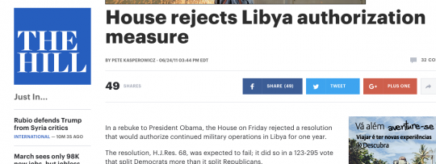](https://prod01-cdn07.cdn.firstlook.org/wp-uploads/sites/1/2017/04/libyavote-1491569775.png)

What happened to Obama as a result of involving the U.S in a war that Congress had rejected? Absolutely nothing, because Congress, due to political cowardice, wants to abdicate war-making powers to the President. As a country, we have decided we want an all-powerful president – one who can bomb, and spy, and detain, and invade with virtually no limits. That’s the machinery of the imperial presidency that both parties have jointly built and [have now handed to President Trump](https://www.washingtonpost.com/posteverything/wp/2016/11/11/glenn-greenwald-trump-will-have-vast-powers-he-can-thank-democrats-for-them/).

Indeed, in 2013, [Obama explicitly argued](https://twitter.com/jacklgoldsmith/status/849744432169660416) that he had the right to bomb Assad without Congressional approval – a precedent the Trump White House will now use.

**5. How can those who view Trump as an Inept Fascist now trust him to wage war?**

Perhaps the most bizarre aspect of the last 24 hours has been watching those who have vilified Trump as an Evil Fascist and Bumbling Clown and Unstable Sociopath suddenly decide that they want him to bomb Syria. Even if you’re someone who in the abstract wanted the U.S. to attack Assad, shouldn’t your view that Trump is a completely unstable and incompetent monster prevent you from endorsing *this war*, with Trump as the Commander-in-Chief?

What happened to all the warnings about Trump’s towering incompetence and core evil? Where are all the grave predictions that he’s leading the world on a path of authoritarianism, fascism and blood and soil nationalism? They all gave way to War Fever:

**[Follow](https://twitter.com/SlaughterAM" \o "Follow Anne-Marie Slaughter on Twitter)**

[https://pbs.twimg.com/profile_images/558632106536882176/iXwSMk4U_normal.jpeg](https://twitter.com/SlaughterAM)**[Anne-Marie Slaughter](https://twitter.com/SlaughterAM)**

[✔@SlaughterAM](https://twitter.com/SlaughterAM)

Donald Trump has done the right thing on Syria. Finally!! After years of useless handwringing in the face of hideous atrocities.

[4:24 AM - 7 Apr 2017](https://twitter.com/SlaughterAM/status/850263058756673540)

[302 Retweets](https://twitter.com/intent/retweet?tweet_id=850263058756673540)

[570 likes](https://twitter.com/intent/like?tweet_id=850263058756673540)

**[Follow](https://twitter.com/SamSacks" \o "Follow Sam Sacks on Twitter)**

[https://pbs.twimg.com/profile_images/849780848731844608/YkugxhO3_normal.jpg**Sam Sacks** @SamSacks](https://twitter.com/SamSacks)

Guest after guest is gushing. From MSNBC to CNN, Trump is receiving his best night of press so far. And all he had to do was start a war.

[9:59 PM - 6 Apr 2017](https://twitter.com/SamSacks/status/850166028738973696)

[12,626 Retweets](https://twitter.com/intent/retweet?tweet_id=850166028738973696)

[16,867 likes](https://twitter.com/intent/like?tweet_id=850166028738973696)

**[Follow](https://twitter.com/peterdaou" \o "Follow Peter Daou on Twitter)**

[https://pbs.twimg.com/profile_images/841626163315318784/HiALzemt_normal.jpg](https://twitter.com/peterdaou)**[Peter Daou](https://twitter.com/peterdaou)**

[✔@peterdaou](https://twitter.com/peterdaou)

I'm a Dem and I oppose [@realDonaldTrump](https://twitter.com/realDonaldTrump)'s policies, but I will fully support appropriate retaliation against [#Assad](https://twitter.com/hashtag/Assad?src=hash)'s war crimes in [#Syria](https://twitter.com/hashtag/Syria?src=hash).

[1:42 PM - 5 Apr 2017](https://twitter.com/peterdaou/status/849678610025906176)

[373 Retweets](https://twitter.com/intent/retweet?tweet_id=849678610025906176)

[1,178 likes](https://twitter.com/intent/like?tweet_id=849678610025906176)

During the campaign, Trump explicitly vowed to commit war crimes: to torture detainees and [purposely murder](http://www.independent.co.uk/news/world/americas/donald-trump-reiterates-desire-to-murder-terrorists-families-a6912496.html) the families of terrorists. Back in April of last year, I [summarized Trump’s mindset this way](https://twitter.com/ggreenwald/status/717346063896743937): “he favors fewer wars, but advocates more monstrous, war-criminal tactics for the ones US does fight.”

Given everything that has been claimed about Trump by his critics, how can any of them justify cheering for a bombing campaign led by him? Do they experience no cognitive dissonance at all in having spent months depicting Trump as a lying, deceitful fascist, only to now turn around and trust him to bomb other countries with care, humanitarianism and efficacy?

**6. Like all good conspiracy theories, no evidence can kill the Kremlin-controls-Trump tale.**

Central to the conspiracy theories woven for months by Democrats is the claim that Putin wields power over Trump in the form of blackmail, debts or other leverage. As a result, this conspiracy theory goes, the Kremlin has now infiltrated American institutions of power and controls the U.S. Government, because Trump is unwilling – indeed, unable – to defy Putin’s orders.

[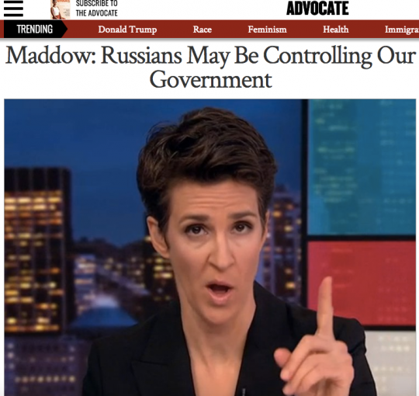](https://prod01-cdn07.cdn.firstlook.org/wp-uploads/sites/1/2017/04/advocate-1491571299.png)

Yet here is Trump – less than three months after being inaugurated – bombing one of the Kremlin’s closest allies, in a country where Russia has spent more than a year fighting to preserve his government. Will any of this undermine or dilute the conspiracy theory that the Kremlin controls the White House? Of course not. Warped conspiracy theorists are not only immune to evidence that disproves their theories but, worse, find ways to convert such evidence into further proof of their conspiracies.

Already, the most obsessive Democratic conspiracists [have cited](https://twitter.com/EricBoehlert/status/850169830116347904) the fact that the U.S. military advised Russia in advance of the strikes – something they would have been incredibly reckless not to do – as [innuendo showing that Trump serves Putin](https://twitter.com/MattBinder/status/850201427062308864). If Trump tomorrow bombed Red Square, Democrats – after cheering him – would quickly announce that he only did so to throw everyone off the trail of his collusion with Putin.

**7. The fraud of humanitarianism works every time for (and on) American elites.**

In the last two months, Trump has ordered a commando raid in Yemen that has massacred children and dozens of innocent people, bombed Mosul and killed scores of civilians, and bombed a mosque near Aleppo that killed dozens. During the campaign, he vowed to murder the family members of alleged terrorists. He shut America’s doors to Syrian refugees, and is deporting people who have lived in the U.S. since childhood despite committing no crimes.

Given all that, could American elites possibly believe him when he says that he is motivated by humanitarianism – deep-seated anger over seeing Syrian children harmed – in bombing Syria? Yes, they could, and they are. That’s because American elites always want to believe – or at least want others to believe – that the U.S. bombs countries over and over not out of aggression or dominance but out of love, freedom, democracy and humanitarian concern.

The U.S. Government does not wage war, and the U.S. military does not blow things up, out of humanitarianism. It does so when it believes there is some benefit to be obtained for itself. Again, Federalist 4 warned us: “nations in general will make war whenever they have a prospect of getting anything by it.”

If humanitarianism is what motivated the U.S. in Syria, it would take in massive numbers of refugees, but it hasn’t. If humanitarianism is what motivated the U.S. bombing of Libya, it would have given large amounts of aid to that country in the aftermath to help it deal with the ensuing anarchy and misery, but it didn’t. That’s because humanitarianism is the pretext for U.S. wars, not the actual motive.

**[Follow](https://twitter.com/Rsherlock" \o "Follow Ruth Sherlock on Twitter)**

[https://pbs.twimg.com/profile_images/784095476664692736/2mrZ3QtG_normal.jpg](https://twitter.com/Rsherlock)**[Ruth Sherlock](https://twitter.com/Rsherlock)**

[✔@Rsherlock](https://twitter.com/Rsherlock)

I was on phone with [#QusaiZakarya](https://twitter.com/hashtag/QusaiZakarya?src=hash), who survived 2013 [#chemical](https://twitter.com/hashtag/chemical?src=hash) attack, when he learned [#Trump](https://twitter.com/hashtag/Trump?src=hash) action: "I'll name my son Donald. Hero."[#Syria](https://twitter.com/hashtag/Syria?src=hash)

[11:57 PM - 6 Apr 2017](https://twitter.com/Rsherlock/status/850195769566965761) · [London, England](https://twitter.com/search?q=place%3A457b4814b4240d87)

[988988 Retweets](https://twitter.com/intent/retweet?tweet_id=850195769566965761)

[1,3111,311 likes](https://twitter.com/intent/like?tweet_id=850195769566965761)

But the psychological comfort of believing that the only reason your government bombs more countries by far than any other is because your country is just so uniquely devoted to humanitarian love is so powerful that it overrides all rational faculties. That’s why all wars – [even the most malicious and aggressive](http://www.salon.com/2012/05/02/the_fraud_of_humanitarian_wars/) – are wrapped in humanitarian packaging. And no matter how many times we see that this packaging is a lie – in Vietnam, in Iraq, in Libya – we keep wanting to believe that, *this time,*our bombs will be filled with love, help and freedom.

**8. Support for Trump’s Bombing Shows Two Toxic U.S. Conceits: “Do Something” and “Look Strong”**

Those who oppose Trump’s new bombing campaign – or any U.S. bombing campaign – are instantly met with the predictable objection: we must “Do Something” about Syria. This mentality is predicated on a terribly false, and terribly dangerous, premise: that the U.S. military can and should solve every world evil.

But sometimes, the U.S. lacks the ability to solve other problems. Often, having the U.S. drop bombs exacerbates suffering, rather than alleviates it. As upsetting as it is to accept, sometimes doing nothing is the least bad of all the options. Again, if humanitarianism really were the motive, there are many things the U.S. could do besides bombing Syria and killing civilians, such as giving refuge and humanitarian aid. But the idea that a war can be justified by appealing to the vague imperative that we must “do something” is incredibly irrational and immoral.

The same is true – indeed even more so – of this horribly toxic premise long endorsed by the world of U.S think tanks that a President must go to war to preserve “credibility” – meaning that he must drop bombs and kill people to show the world that he, and the country he leads, is “strong.” To see that hideous premise in action, look at how the New York Times gloriously depicted Bush 41’s senseless invasion of Panama in the above article, or how the NYT [yesterday described](https://www.nytimes.com/2017/04/06/world/middleeast/us-said-to-weigh-military-responses-to-syrian-chemical-attack.html?hp&action=click&pgtype=Homepage&clickSource=story-heading&module=a-lede-package-region&region=top-news&WT.nav=top-news) the view of “experts” about Trump’s need to bomb Syria:

[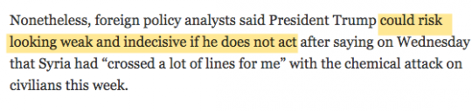](https://prod01-cdn07.cdn.firstlook.org/wp-uploads/sites/1/2017/04/risk-1491572688.png)

There may be some things more evil and immoral than starting a new war based on the desire to avoid “looking weak,” but it’s hard to think of many things that qualify. And yet this belief continues to be gospel among America’s war-loving think tank and Foreign Policy Community.

**9. Obama’s refusal to bomb Assad hovers over everything.**

Despite insisting that he had the power to do so without Congress, Obama resisted bipartisan demands to use military force against Assad. I personally view this as one of Obama’s smartest and best decisions and, according to today’s New York Times, so does he: “Mr. Obama said he was ‘very proud of that moment’ because he had stepped back from the Washington establishment’s warnings. Few of his top foreign policy advisers agreed.” Indeed, by the end of his presidency, the U.S. [stopped claiming](https://www.theguardian.com/us-news/2015/jan/25/us-syrian-regime-change-isis-priority) it was even seeking regime change.

But those who insist that the U.S. has a moral obligation to remove Assad or at least bomb him become tongue-tied when it comes to assessing Obama. If, as many claim, Assad is our generation’s Hitlerian figure – and recall how many recent foreign leaders [were depicted as The New Hitler](http://www.haaretz.com/israel-news/far-right-mk-assassinating-ahmadinejad-today-is-like-assassinating-hitler-in-1939-1.318881) when some wanted them attacked –  does that make Obama this generation’s Neville Chamberlain for his refusal to attack Assad? And does it mean that Trump has acted more morally than Obama by doing what Obama refused to do?

Again, I side with Obama in this dispute because I never believed that U.S. military had any positive role to play in Syria. But those who have long insisted that U.S. military action against Assad is morally imperative should follow those premises through to their conclusions when it comes to Obama and Trump.

**10. None of this disproves, obviously, that Hillary Clinton was also a dangerous hawk.**

Every time Trump drops another bomb, Democratic pundits declare vindication over those always-unnamed people who they claim argued during the campaign that Trump was more anti-war than Clinton:

**[Follow](https://twitter.com/JamesFallows" \o "Follow James Fallows on Twitter)**

[https://pbs.twimg.com/profile_images/800451796690997250/eukWDo7n_normal.jpg](https://twitter.com/JamesFallows)**[James Fallows](https://twitter.com/JamesFallows)**

[✔@JamesFallows](https://twitter.com/JamesFallows)

You people who were warning that HRC was the “real hawk”:  
  
Go to hell. [https://twitter.com/HeerJeet/status/850155898202763264 …](https://t.co/KHTbnL3cb4)

[9:20 PM - 6 Apr 2017](https://twitter.com/JamesFallows/status/850156341003866112)

[811 Retweets](https://twitter.com/intent/retweet?tweet_id=850156341003866112)

[1,5351,535 likes](https://twitter.com/intent/like?tweet_id=850156341003866112)

Who are the people who argued that Trump would be more anti-war than Clinton? Their numbers were tiny; Maureen Dowd is one of the very people with a prominent platform [to claim this](https://www.nytimes.com/2016/05/01/opinion/sunday/donald-the-dove-hillary-the-hawk.html). Trump expressly vowed to bomb more frequently and more aggressively, [as was often pointed out](https://twitter.com/ggreenwald/status/777882037877350400).

It’s certainly true that any attempt by Trump to remove Assad would violate his oft-stated campaign vows. But whatever else is true, this specific bombing campaign is a bizarre instance to try to defend Clinton given that Clinton, for years – and again *yesterday* – endorsed this military action. Indeed, Clinton has long endorsed far more extensive military action in Syria than what Trump yesterday ordered, often advocating [a no-fly-zone over parts of Syria](http://www.huffingtonpost.com/entry/hillary-clinton-syria-no-fly-zone-third-debate_us_58084280e4b0180a36e91a53) – which would be a massive and incredibly dangerous military undertaking – and even yesterday calling for the destruction of Assad’s air force.

It’s certainly true that Trump vowed to involve the U.S. in fewer wars than Clinton wanted, and for a narrower range of reasons. And that may still end up happening. Indeed, many of Trump’s most vocal supporters yesterday were expressing anger even over this limited bombing campaign in Syria. But to take a military action that *Clinton herself favored* and try to use it to suggest that Clinton would have been less hawkish is just bizarre and deceitful beyond belief.

Ultimately, what is perhaps most depressing about all of this is how, yet again, we see the paucity of choice offered by American democracy. The leadership of both parties can barely contain themselves joining together to cheer the latest war.

* One candidate – the losing one – ran on a platform of launching this new war, while
* the other – the victor – repeatedly vowed to avoid it, only to launch it after being in office fewer than 100 days.

The one constant of American political life is that the U.S. loves war. Martin Luther King’s 1967 denunciation of the U.S. as “the greatest purveyor of violence in the world today” is more accurate than ever.

**UPDATE**: While Prime Minister Trudeau yesterday urged an investigation before any action is taken, once Trump’s bombs fell, he [issued a statement](https://www.nytimes.com/interactive/2017/04/07/world/middleeast/world-reactions-syria-strike.html) expressing full support, directly contradicting his earlier statements: “President Assad’s use of chemical weapons and the crimes the Syrian regime has committed against its own people cannot be ignored.”

**CONTACT THE AUTHOR:**

[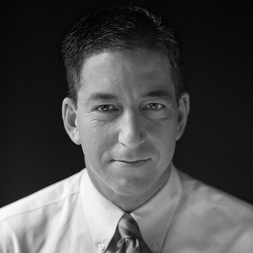](https://theintercept.com/staff/glenn-greenwald/)

[Glenn Greenwald](https://theintercept.com/staff/glenn-greenwald/)[✉glenn.greenwald@​theintercept.com](mailto:glenn.greenwald@theintercept.com)[t@ggreenwald](https://twitter.com/@ggreenwald)